Langkampfen, 9 May 2023

STIHL Tirol: A successful year despite difficult conditions
- Turnover increase of 7 percent to 768.9 million euros in 2022
- Major challenges: disrupted supply chains and material shortages
- Urgent staffing requirements
- New plastics manufacturing facility in production since September 2022
- New central warehouse in Völklingen
- Innovations for a sustainable future
STIHL Tirol GmbH was able to continue its positive economic development in the 2022 financial year. The garden equipment manufacturer and cordless product specialist grew once again despite various challenges in the past financial year. Turnover increased by 7 percent to 768.9 million euros (previous year 715.8 million euros). The number of employees rose slightly in 2022, increasing by 4 percent from 770 to 799.
Purchasing at STIHL Tirol faced immense challenges due to global delivery bottlenecks caused by the pandemic in the previous year. There was a lack of electronic components in particular and, as the demand for lawn mowers, hedge trimmers and other garden tools made by STIHL Tirol remained high, especially in the cordless segment, this led to an increase in production backlogs. Purchasing and logistics were particularly challenged; new delivery companies had to be found and new transport routes had to be checked.
Jan Grigor Schubert, managing director of STIHL Tirol: “Thanks to our committed employees, the efforts made by the entire STIHL Group and the great loyalty of our customers, we have been able to successfully master this situation. We are now also well equipped for the future thanks to the additional independence granted by our own plastics manufacturing facility. In 2022, we were able to achieve stable growth and continue our successful development.”
In addition to disrupted supply chains and material shortages, 2022 was also marked by economic and geopolitical challenges such as the war in Ukraine, the energy crisis and inflation. The extremely difficult labour market meant that not all vacancies could be filled, many still remain open today.

Urgent staffing requirements
Thanks to creative ideas and successful personnel marketing, the STIHL Tirol team was able to grow to 799 employees over the course of the last year. The company is currently recruiting, especially in the areas of development, plastics manufacturing, production and purchasing.
Existing employees appreciate the company’s attractive social benefits, such as company health promotion and extensive further training measures. Just recently, staff received a voluntary performance bonus, which amounted to an average of 1,200 euros gross per employee. STIHL Tirol also recently introduced the industry-standard three shift pattern, while taking into account the existing needs of the workforce. At the popular “Job Monday at STIHL Tirol” event, which takes place almost every first Monday of the month from 3pm to 6pm and can be visited without prior registration, interested parties have the opportunity to spend an afternoon in a relaxed and friendly setting where they will gain exciting insights into the world of work at the Tyrolean location of the STIHL Group. An apprenticeship campaign was also launched on social media based on the motto “Lehre gegen Leere” (“Apprenticeships against aimlessness”). Other innovative formats were also intensified, for example the NEW ONE employee recommendation programme and collaboration with nearby universities. The successful recruiting measures are reflected in the top ranking achieved in the BEST RECRUITERS study. STIHL Tirol was awarded the silver seal of quality again in 2022 and moved up to second place in the Industry category.

New plastics manufacturing facility in production since September 2022
The new plastics manufacturing facility was successfully opened last September and has been serving STIHL Tirol assembly lines in series production ever since. The facility, at 3,500 m², includes ten injection moulding machines and plenty of space for a future expansion of the plastics production and further assembly lines. Thanks to the new facility, numerous components required for products made on site can be manufactured in Langkampfen. This will make STIHL Tirol even more independent of supply chains in the future. In addition, logistics costs and truck journeys can be reduced, more jobs are created and the workload on incoming goods is reduced. The manufacturing cost of products has also noticeably decreased as a result. The new plastics manufacturing facility is a strong commitment to the Langkampfen site and strengthens local development and production.

Development and automation
When the latest generation of an innovation or product hits the market, the developers and designers involved, as well as the technicians and very often also the employees in production in Langkampfen, look at the result with pride and joy. The new generation of iMOW robotic mowers, which were launched in spring 2023, were co-developed by the Tyrolean team. New product groups were also introduced in 2022, such as water pumps and 19 different models of zero-turn ride-on mowers for the US market. In production, numerous new STIHL products such as cordless chainsaws and cordless blowers have been in production since the end of 2022. On the assembly lines, important steps were made towards automation. The increasing degree of automation improves efficiency but also adds quality for employees. At STIHL Tirol, automation, top quality products, occupational safety and job satisfaction go hand in hand, making work significantly easier.

New central warehouse in Völklingen
For STIHL Tirol, the new central warehouse, which went into operation in November 2022 in Völklingen, Germany, has very special significance. STIHL Tirol was entrusted with operational management. In addition, all of the tools and cordless products produced in Tyrol are stored at the new logistics and distribution site and shipped from there to all STIHL sales subsidiaries and specialist dealers worldwide. The modern new building, which covers an area of around 58,000 m², provides the entire STIHL Group with additional storage capacity and faster, more efficient logistics to ensure customer-oriented market supply.

Innovations for a sustainable future
STIHL is continuing its drive towards climate neutrality with a comprehensive sustainability strategy. The aim is to anchor sustainable criteria in all decision-making processes. The many activities already in place will be intensified and work will continue to be carried out in a fair and material-efficient manner. In Tyrol, the company started to introduce measures for an economical approach towards energy and the efficient use of all resources many years ago. These include converting the fleet of company vehicles to hybrid and electric vehicles, installing carbon filter systems to reduce heating costs and switching to LED lighting. The photovoltaic system on the roof of the company building in Langkampfen is currently being expanded again. Innovations in the battery sector are an important building block when it comes to reducing greenhouse gas emissions. The focus here is on optimising and expanding the battery product portfolio. At the same time, the STIHL Group is working on the development of almost climate-neutral fuels in order to make products with combustion engines sustainable and environmentally friendly. Processes in production are also being made even more efficient and resource-friendly.

Facts & figures

Company history
1981 Founded as VIKING GmbH
1992 VIKING becomes a STIHL Group company
2001 Relocation of the company headquarters from the Austrian town of Kufstein to the centre of excellence for gardening tools in Langkampfen
2007 First expansion of the VIKING plant at the Langkampfen location
2012 Second expansion of the plant to provide additional floor space
2018 The company is renamed STIHL Tirol GmbH, brand migration from VIKING to STIHL
2019 The third large expansion is officially inaugurated
2022 Fourth expansion of the plant - start of operations at the new plastics manufacturing facility

Product range
Lawn mowers, robotic mowers, ride-on mowers, garden shredders, lawn scarifiers, tillers, chainsaws, brushcutters, pole pruners, vacuum shredders, hedge trimmers, long-reach hedge trimmers, KombiEngines, blowers, cut-off machines, special harvesters, water pumps. Many of these products are available as cordless, electric and petrol tools.

Business figures
 | 2018 | 2019 | 2020 | 2021 | 2022
Employees | 558 | 639 | 702 | 770 | 799
Turnover in € 1000 | 385,700 | 456,100 | 576,200 | 715,800 | 768,900

Information about STIHL Tirol
STIHL Tirol GmbH is a wholly owned subsidiary of the STIHL Group and is based in Langkampfen, Austria. Cordless products are produced at this site and STIHL Tirol is also a centre of excellence for ground-based gardening tools, which are produced and developed in Langkampfen. In 2022, the company employed 799 people.

STIHL company profile
The STIHL Group develops, manufactures and distributes motorised equipment for forestry, agriculture, landscape management, the building industry and private garden owners. The product range is supplemented with digital solutions and services. Products are generally distributed through specialist dealers and STIHL's own online shops, which will be expanded internationally over the next few years. This includes 42 sales and marketing STIHL subsidiaries, around 120 importers and more than 55,000 specialist dealers in over 160 countries. STIHL manufactures products in seven countries worldwide: Germany, USA, Brazil, Switzerland, Austria, China and the Philippines. STIHL has been the best-selling chainsaw brand worldwide since 1971. The company was founded in 1926 and the corporate headquarters are in Waiblingen near Stuttgart, Germany. In 2022, STIHL had 20,552 employees worldwide and a turnover of 5.49 billion euros.

Your contact for further questions
STIHL Tirol GmbH
Mag. Christian Dag
Hans Peter Stihl-Straße 5
6336 Langkampfen
Austria
Tel: +43 (0) 5372 6972 267
Email: christian.dag@stihl.at
www.stihl-tirol.at

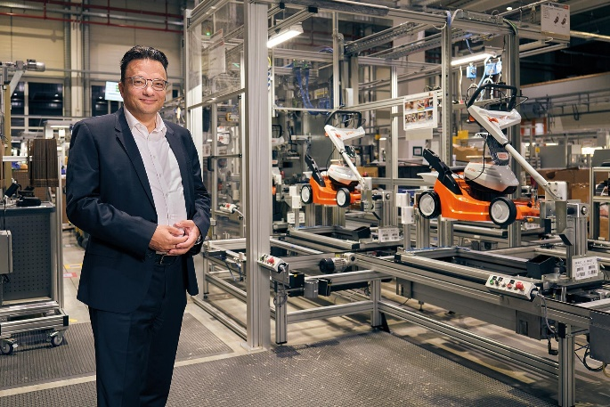
Image 1

Jan Grigor Schubert, Managing Director of STIHL Tirol GmbH
Jan Grigor Schubert, Managing Director of STIHL Tirol GmbH, at one of the numerous assembly lines for cordless products. At STIHL Tirol, everyone is looking forward to continuing the successful course embarked on in recent years under new management.
Reprints free of charge for press purposes, photo credit: STIHL Tirol

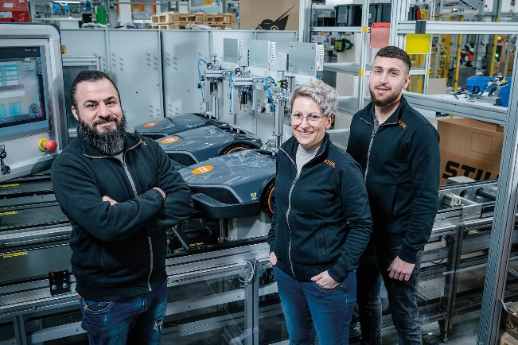
Image 2

STIHL Tirol is growing steadily and hiring
STIHL Tirol is always on the lookout for committed individuals to join the team at one of the region's most innovative companies. The picture shows part of the assembly line team for the new generation of iMOW robotic mowers.
Reprints free of charge for press purposes, photo credit: STIHL Tirol

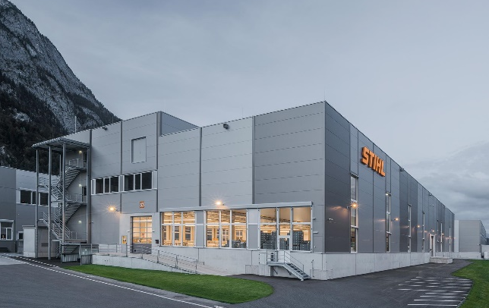
Image 3

Successful commissioning of the new plastics manufacturing facility
The new plastics manufacturing facility was successfully opened last September and has been serving STIHL Tirol assembly lines in series production ever since. The extension building, which represented an investment of approximately 19 million euros, is a strong commitment by the STIHL Group to the Langkampfen location.
Reprints free of charge for press purposes, photo credit: STIHL Tirol

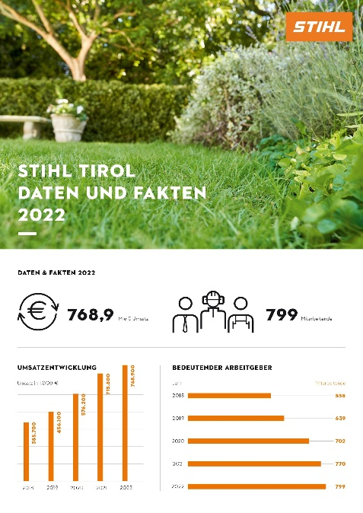
Image 4

STIHL Tirol is growing sustainably
STIHL Tirol GmbH continued its positive economic development in 2022 and increased turnover by seven percent to 768.9 million euros. The number of employees rose to 799 in 2022.
Reprints free of charge for press purposes, photo credit: STIHL Tirol

