Langkampfen, 26 May 2021

STIHL Tirol continues its success story yet again in 2020
- A considerable increase in sales despite adverse conditions
- Successful process optimisation in production activities
- A new plastics manufacturing facility in Langkampfen from 2022
- 30 job vacancies currently available

In the 2020 business year, STIHL Tirol GmbH increased its turnover to 576.2 million euros, which represents growth of more than 26 percent compared to 2019. It also increased its overall number of staff by almost 10 percent in 2020, with 702 employees now working in the STIHL Tirol team. As these figures show, the company was able to continue its positive economic development yet again in 2020.
A significant factor behind this gain in sales was the high demand for lawn mowers, hedge trimmers and other gardening tools from STIHL Tirol. According to the managing director of STIHL Tirol, Clemens Schaller, one reason for this demand was the fact that many people spent more time at home and invested more money in their homes and gardens due to contact and travel restrictions. This "cocooning effect" caused many people to take an enthusiastic approach to tending to their gardens, which acted as havens of peace and relaxation during a difficult period and continue to do so in the present day.
The industry trend towards cordless products is still going strong, and the STIHL Group's battery production facility recorded constant growth in the number of units manufactured in this segment. Further growth was additionally observed in the robotic mowers product group. There was also plenty of demand for the Tyrolean gardening equipment manufacturer's long-standing lead products, for example petrol lawn mowers.
The location in Langkampfen produces lawn mowers, robotic mowers, ride-on mowers, garden shredders, lawn scarifiers, tillers, chainsaws, brushcutters, pole pruners, vacuum shredders, hedge trimmers, KombiMotors, long-reach hedge trimmers, blowers, cut-off machines and special harvesters. Many of these products are available as cordless, electric or petrol tools.

A strict hygiene concept protects staff and safeguards production in Tyrol
The measures introduced at STIHL Tirol in spring 2020, right at the start of the Covid-19 pandemic, have remained in place ever since and helped the gardening equipment manufacturer to successfully overcome this unprecedented situation. These strict hygiene measures enabled the company to safeguard the health of all employees, thus allowing its production work and other operational activities to continue without interruption. Furloughs and the part-time "Kurzarbeit" scheme were never an issue, and the company was able to fulfil the high demand for STIHL tools "made in Tyrol". Looking back on the year, Clemens Schaller, the managing director of STIHL Tirol, reports that: "I am extremely proud of how we have mastered the many challenges faced over the past few months and were able to bring 2020 to a close with a significant increase in sales. I would very much like to thank our employees for their consistent implementation of all safety measures, their commitment and their willingness to take new approaches."

Successful process optimisation in production activities
In addition to the growing demand for STIHL tools from STIHL Tirol and the high quality of these products, another reason behind the company's successful development is the continuous improvement of its production activities, facilities and processes. With the aim of remaining a strong force in the future, the company is constantly implementing optimisation solutions and measures to make processes more effective at the heart of its value creation: production. Process optimisation during series production helped to reduce disruptions, improve the material flow and raise efficiency. As a result, the company was ultimately able to increase its production capacities at short notice to meet the strong market demand. STIHL Tirol is currently strengthening its focus on semi-automated processes and software support. In line with this focus, it also recently upgraded its semi-automated packing processes. State-of-the-art technology is now used for weighing, packing and labelling, thus resulting in higher process reliability and ultimately higher quality.

A new plastics manufacturing facility in Langkampfen from 2022

At the end of April 2021, a symbolic ground-breaking ceremony was held for a new plastics manufacturing facility on the company premises in Langkampfen. The new building is being constructed on a newly developed site covering an area of 3,500 m², which provides space for a facility that will initially have ten injection moulding machines and space for new assembly lines in the future. The project represents an investment of around 19 million euros.
This step comes 40 years after the company was founded in early 1981 and represents a renewed commitment to the location, underlining its importance within the STIHL Group. The company decided to go ahead with the expansion due to positive and stable growth over the past few years and continued good prospects for the future. With this new development, STIHL Tirol is committed to intensifying its in-house manufacturing activities, as the supply of many plastic parts will be secured directly on-site in the future. The new plastics manufacturing facility has many advantages. It reduces the cost of production and logistics, and the elimination of truck journeys improves life-cycle assessment. In addition, new jobs will be created for an additional 50 employees in Langkampfen. The expansion will be completed in summer 2022.

Employees wanted

STIHL Tirol is always on the lookout for committed individuals who want to join the team at one of the region's most innovative companies. As part of the internationally successful STIHL Group, the company combines economic stability with a relaxed corporate culture. Employees at the gardening tool manufacturer and battery product specialist benefit from a wide range of different working time models, a voluntary travel allowance and a company pension scheme. There is also a company restaurant with reduced meal prices and a number of other attractive benefits. For the past financial year, staff also received a discretionary corona bonus and a discretionary performance bonus.
The gardening tool manufacturer is currently looking for motivated applicants, especially in the areas of assembly, quality management and product development. Open positions are also available in technical communication and purchasing, as well as opportunities for student employees. The company offers prospects for further development, for example the majority of management positions are filled internally.

Facts & figures

Company history
1981 Founding of VIKING GmbH
1992 VIKING becomes a STIHL Group company
2001 Relocation of the company headquarters from the Austrian town of Kufstein to the centre of excellence for gardening tools in Langkampfen
2007 The first expansion of the VIKING plant
2012 The second expansion of the plant to provide additional floor space
2018 The third large expansion of the plant, the company is renamed STIHL Tirol GmbH, brand migration from VIKING to STIHL
2019 The third expansion is officially inaugurated
2021 Ground-breaking of the new plastics manufacturing facility

Product range
Lawn mowers, robotic mowers, ride-on mowers, garden shredders, lawn scarifiers, tillers, chainsaws, brushcutters, pole pruners, vacuum shredders, hedge trimmers, long-reach hedge trimmers, KombiMotors, blowers, cut-off machines, special harvesters.
Many of these products are available as cordless, electric and petrol tools.

Business figures
 | 2016 | 2017 | 2018 | 2019 | 2020
Employees | 414 | 480 | 558 | 639 | 702
Turnover in € 1000 | 266,900 | 381,800 | 385,700 | 456,100 | 576,200

Information about STIHL Tirol
STIHL Tirol GmbH is a wholly owned subsidiary of the STIHL Group and is based in Langkampfen, Austria. Cordless products are produced at this site and STIHL Tirol is also a centre of excellence for ground-based gardening tools, which are produced and co-developed in Langkampfen. In 2020, the company employed 702 people.

STIHL company profile
The STIHL Group develops, manufactures and distributes motorised equipment for forestry, agriculture, landscape management, the building industry and private garden owners. The product range is supplemented with digital solutions and services. Products are generally distributed through specialist dealers and STIHL's own online shops, which will be expanded internationally over the next few years. This includes 41 sales and marketing STIHL subsidiaries, around 120 importers and more than 54,000 specialist dealers in over 160 countries. STIHL manufactures products in seven countries worldwide: Germany, USA, Brazil, Switzerland, Austria, China and the Philippines. STIHL has been the best-selling chainsaw brand worldwide since 1971. The company was founded in 1926 and the corporate headquarters are in Waiblingen near Stuttgart, Germany. In 2020, STIHL had 18,200 employees worldwide and a turnover of € 4.58 billion.

Your contact for further questions
STIHL Tirol GmbH
Mag. Christian Dag
Hans Peter Stihl-Straße 5
6336 Langkampfen
Austria
Tel: +43 5372 6972 267
Email: christian.dag@stihl.at
www.stihl-tirol.at

Image titles

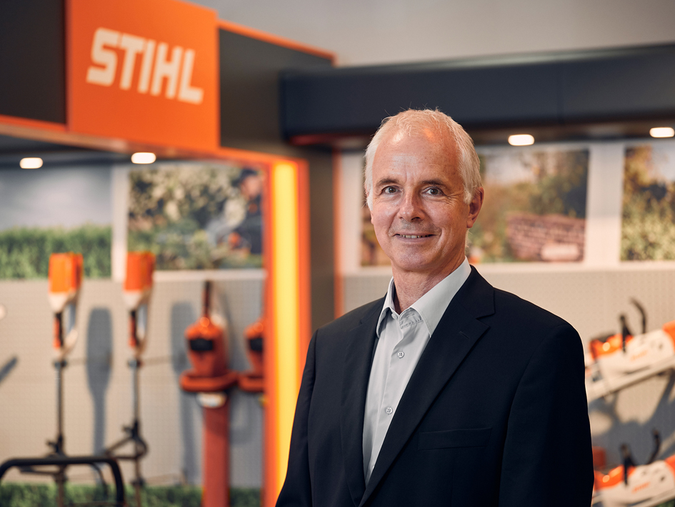
Clemens Schaller, Managing Director of STIHL Tirol GmbH
Clemens Schaller, the managing director of STIHL Tirol GmbH, is pleased with the high demand for gardening tools and the increase in sales despite difficult circumstances.
Reprints free of charge for press purposes, photo credit: STIHL Tirol
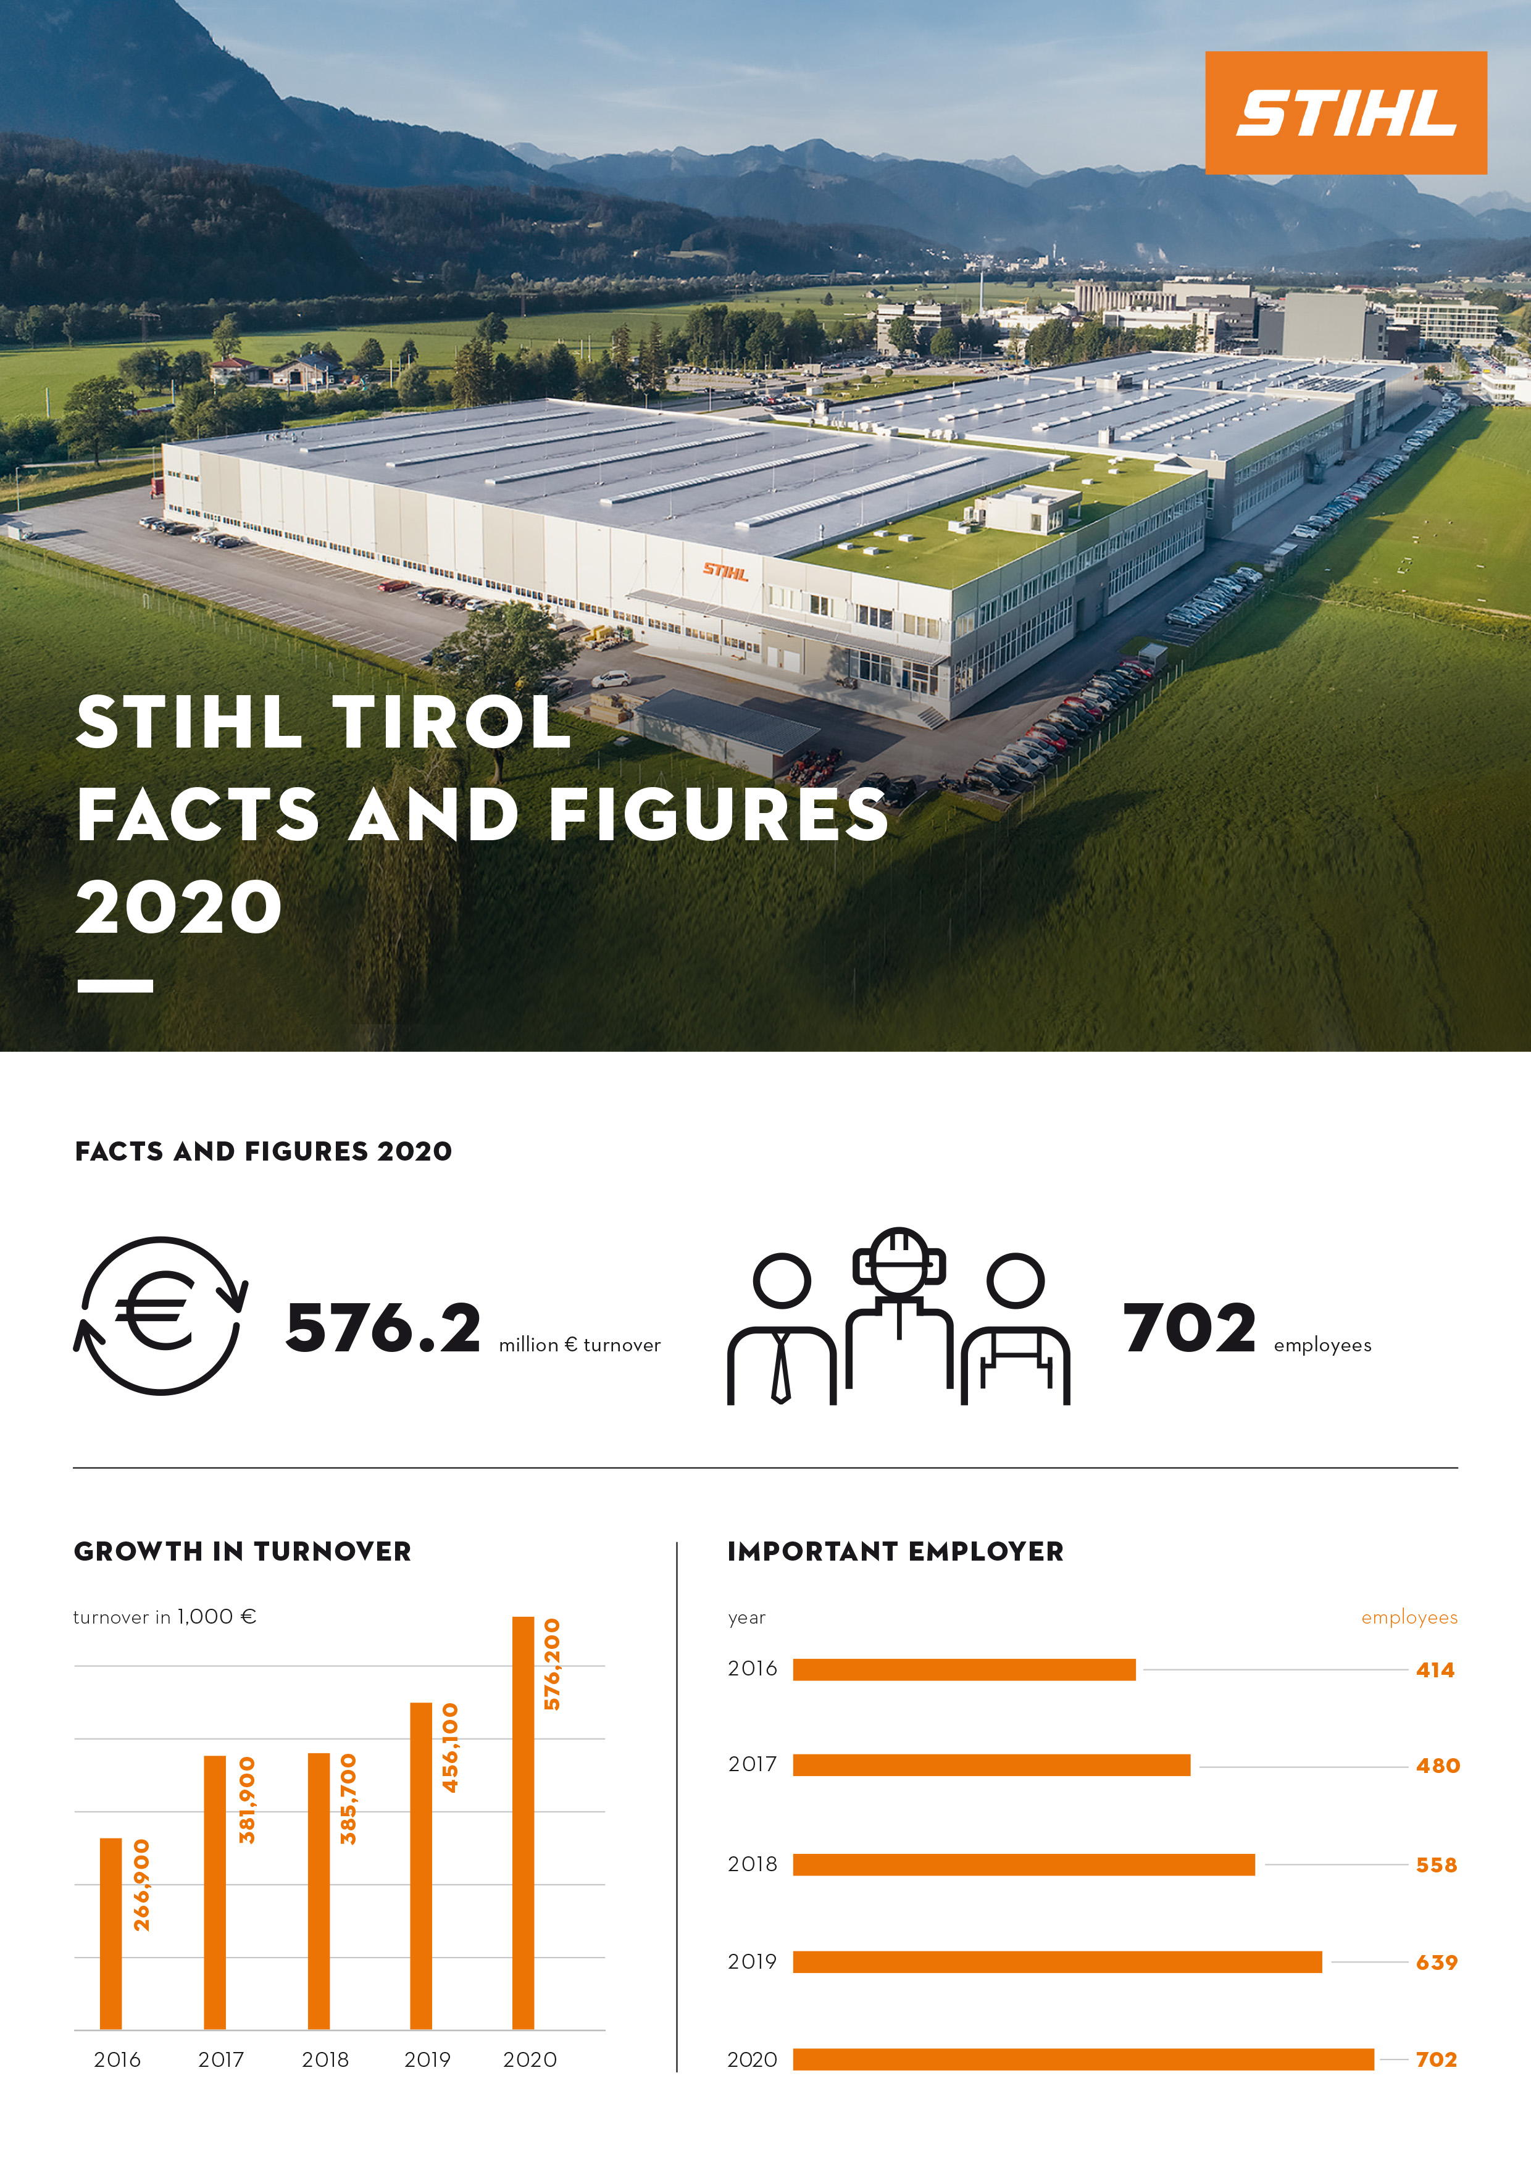
A considerable increase in sales at STIHL Tirol
STIHL Tirol increased its turnover to 576.2 million euros, which represents a growth of more than 26 percent compared to 2019. The number of employees rose to 702.
Reprints free of charge for press purposes, photo credit: STIHL Tirol

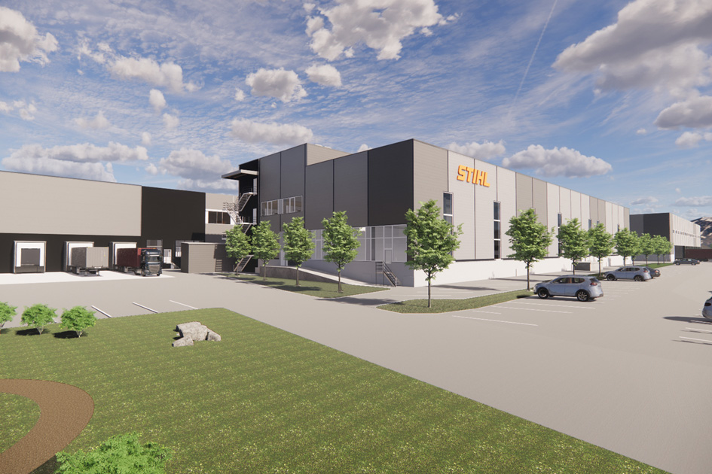
A new plastics manufacturing facility in Langkampfen from 2022
The extension will be built on a newly developed site covering an area of 3,500 m² south of the existing building. The project represents an investment of around 19 million euros.
Reprints free of charge for press purposes, photo credit: STIHL Tirol

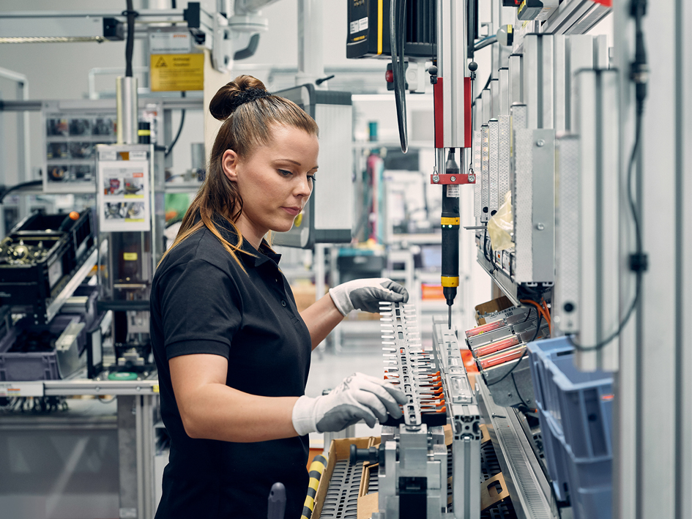
Employees wanted
STIHL Tirol is always on the lookout for committed individuals who want to join the team at one of the region's most innovative companies. The gardening tool manufacturer is currently looking for motivated applicants for positions in numerous areas.
Reprints free of charge for press purposes, photo credit: STIHL Tirol

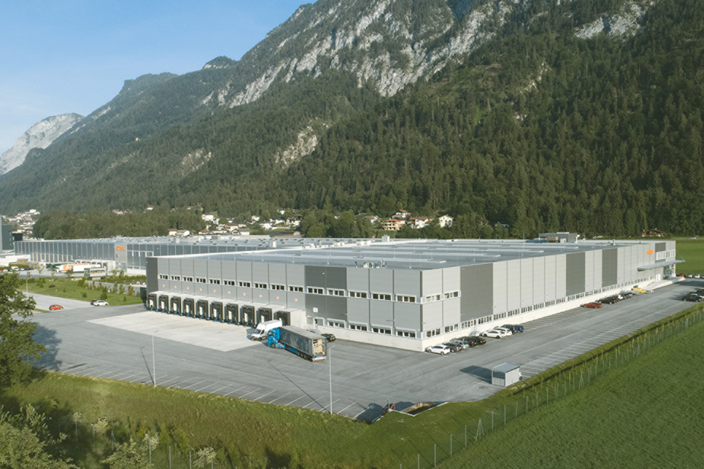
STIHL Tirol
One reason behind the successful development of the Tyrolean garden equipment manufacturer and cordless tool specialist is the continuous improvement of its production activities, facilities and processes.
Reprints free of charge for press purposes, photo credit: STIHL Tirol

