Langkampfen, 20th May 2020

STIHL Tirol records growth in 2019 and defies the corona crisis
- A successful 2019
- Innovative training initiative "Launch your career at STIHL Tirol" started
- Awards "We are inclusive" and "klimaaktiv"

The Corona crisis has severely affected western Austria and Tyrol in particular. Nevertheless, the garden equipment manufacturer STIHL Tirol, based in Langkampfen, has been able to keep all its staff employed over the past weeks and months without having to switch to the part-time "Kurzarbeit" scheme. Strict hygiene measures have been implemented, the two-shift operation has been upheld and assembly lines undergo intensive cleaning between shifts. The supply of parts, even from supply regions such as Asia and northern Italy, could largely be guaranteed. As a result, following the slight easing of restrictions, the company has been able to meet the uninterrupted demand for STIHL devices "made in Tyrol". According to Clemens Schaller, the managing director of STIHL Tirol: "Together we have managed to provide optimal protection for the health of the employees at our company, to continue production at a high level and to meet the increasing demand for our products. I would like to thank all our employees for consistently implementing all the hygiene measures and other regulations we have introduced."

A successful 2019
STIHL Tirol GmbH continued its positive economic development in 2019 and increased turnover to over 456 million euros, which represents growth of 18 percent compared to 2018. The number of employees at STIHL Tirol also rose in line with the business trend from 558 in 2018 to 639 in 2019, an increase of more than 14 percent. The Langkampfen site has benefited from the international appeal of the STIHL brand, both in Europe and North America, both of which are particularly important sales regions. Special product developments, such as a tiller to meet specific requirements in India, also targeted new markets where gardening tools from Tyrol had not previously been represented. The product range, which is manufactured in Langkampfen for the world market, has become even more extensive in recent years and now extends from lawn mowers to robotic mowers, ride-on mowers, garden shredders, lawn scarifiers, tillers, chainsaws, brushcutters, pole pruners, vacuum shredders, hedge trimmers, long-reach hedge trimmers, blowers and even cut-off machines and special harvesters. Many products are not only available with petrol engines, but also as cordless and electric tools. The portfolio also includes niche products such as equipment for harvesting olives in southern Europe. The export quota was 98 percent in 2019. The trend towards cordless tools continues, especially in the European market. STIHL Tirol was able to further expand its segment of cordless products.

Adaptation of internal structures and processes
The successes of the past few years are not only reflected in sales and employee figures; last year three new assembly lines were also commissioned. The internal processes at STIHL Tirol are being adapted to suit current requirements. This includes lean management structures and increased transparency between employees and managers, which is achieved through "shop floor management". This instrument used in production includes short daily meetings and helps to ensure weak points are addressed directly and that solutions are found quickly. In addition to this, a project was completed last year to improve the flow of materials.

Space for development
The extension building that was opened in 2019 has provided new and attractive office spaces as well as 25 new high-tech product testing rooms, an electronics laboratory and a 3,000 m² test area for robotic mowers on the company roof. The equipment is state-of-the-art. With these facilities for endurance testing, STIHL Tirol has created ideal conditions for innovation and an attractive working environment for developers with different qualifications and experience.

Launch your career at STIHL Tirol
STIHL Tirol is one of the most important employers in the local region. The continued development of the centre of excellence and production site in Langkampfen is based on the knowledge and experience of the employees. For this reason, the company places special emphasis on promoting the professional development of staff. The unique and innovative training initiative "Launch your career at STIHL Tirol" is currently being implemented in collaboration with the Tyrolean Vocational Training Institute (BFI) at Innotech Kufstein. Motivated STIHL Tirol employees have the opportunity to acquire basic technical knowledge in mechatronics and metal technology by means of an additional external basic training programme. The goal is to complete a mechatronics or metal technology apprenticeship as a "second-chance" educational programme. The new model, which is to be further expanded in the future, has commenced with eleven participants of various different nationalities who were selected through an application process. More will follow.

Job vacancies

STIHL Tirol is always on the lookout for committed individuals who want to join the team at one of the region’s most innovative companies. The gardening tool manufacturer is currently looking for motivated applicants for positions in the areas of assembly, quality management, product development and purchasing. Skilled workers and engineers are among the most sought-after professional groups.

We are inclusive
STIHL Tirol has been awarded the "We are inclusive" seal of approval by the Social Ministry Service in Tyrol for the second time and has thus been recognised once again for its exemplary commitment to the employment of people with disabilities. Social responsibility plays a major role at STIHL Tirol. By employing people with disabilities, the company wants to safeguard their opportunities, open up new perspectives and support them in leading an independent life. STIHL Tirol often awards open bid contracts to regional institutions that employ people with disabilities. For example, the company works with Lebenshilfe Kufstein, a social organisation for people with disabilities.

STIHL Tirol wins the “klimaaktiv” award
STIHL Tirol was one of 25 Austrian companies to be presented with an award in recognition of its extraordinary commitment to energy efficiency and climate protection again at the end of 2019. The garden equipment manufacturer is one of 13 companies in Austria that have voluntarily undertaken to continuously reduce their energy consumption as part of a climate protection initiative. By installing a photovoltaic system, the company from the Austrian town of Langkampfen is now able to save 51,600 kWh or 14 tonnes of CO2 every year. In previous years, it already achieved similar power savings by switching over to LED lighting in many areas of the company.

Facts & figures

Company history
1981 Founding of VIKING GmbH
1992 VIKING becomes a STIHL Group company
2001 Relocation of the company headquarters from the Austrian town of Kufstein to the centre of excellence for gardening tools in Langkampfen
2007 The first expansion of the VIKING plant
2012 The second expansion of the plant to provide additional floor space
2018 The third large expansion of the plant, the company is renamed STIHL Tirol GmbH, brand migration from VIKING to STIHL
2019 The extension is officially inaugurated

Product range
Lawn mowers, robotic mowers, ride-on mowers, garden shredders, lawn scarifiers, tillers, chainsaws, brushcutters, pole pruners, vacuum shredders, hedge trimmers, long-reach hedge trimmers, blowers, cut-off machines, special harvesters.
Many of the products are available as cordless, electric and petrol tools.

Business figures
 | 2015 | 2016 | 2017 | 2018 | 2019
Employees | 373 | 414 | 480 | 558 | 639
Turnover in € 1000 | 193,900 | 266,900 | 381,800 | 385,700 | 456,100

Information about STIHL Tirol
STIHL Tirol GmbH is a wholly owned subsidiary of the STIHL Group and is based in Langkampfen, Austria. Cordless products are produced at this site and STIHL Tirol is also a centre of excellence for ground-based gardening tools, which are produced and co-developed in Langkampfen. In 2019, the company employed 639 people.

STIHL company profile
The STIHL Group develops, manufactures and distributes motorised equipment for forestry, agriculture, landscape management, the building industry and private garden owners. The product range is supplemented with digital solutions and services. Products are generally distributed through specialist dealers – including 41 sales and marketing STIHL subsidiaries, around 120 importers and more than 53,000 specialist dealers in over 160 countries. STIHL manufactures products in seven countries worldwide: Germany, USA, Brazil, Switzerland, Austria, China and the Philippines. STIHL has been the best-selling chainsaw brand worldwide since 1971. The company was founded in 1926 and the corporate headquarters are in Waiblingen near Stuttgart, Germany. In 2019, STIHL had 16,722 employees worldwide and a turnover of € 3.93 billion.

Your contact for further questions
STIHL Tirol GmbH
Mag. Christian Dag
Hans Peter Stihl-Straße 5
6336 Langkampfen
Austria
Tel: +43 5372 6972 267
Email: christian.dag@stihl.at
www.stihl-tirol.at

Image titles

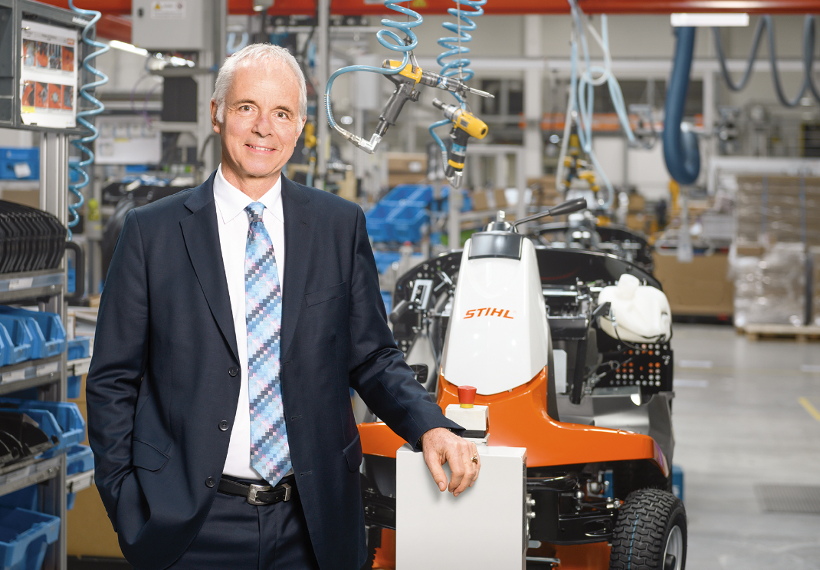
Clemens Schaller, Managing Director of STIHL Tirol GmbH
Clemens Schaller, the managing director of STIHL Tirol GmbH, is happy about the successful year experienced in 2019. Even during the corona crisis, the garden equipment manufacturer was able to keep all staff fully employed.
Reprints free of charge for press purposes, photo credit: STIHL Tirol

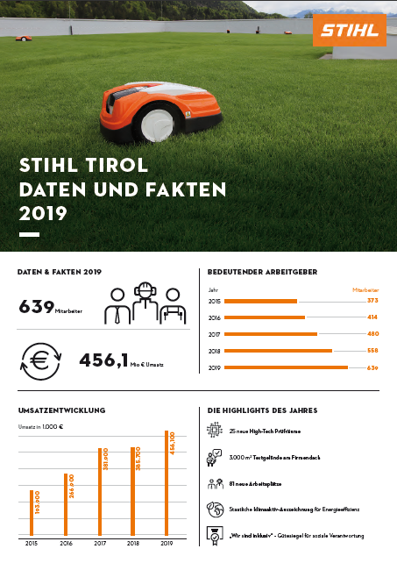
A successful 2019
STIHL Tirol was able to increase turnover to over 456 million euros, the number of employees rose to 639.
Reprints free of charge for press purposes, photo credit: STIHL Tirol

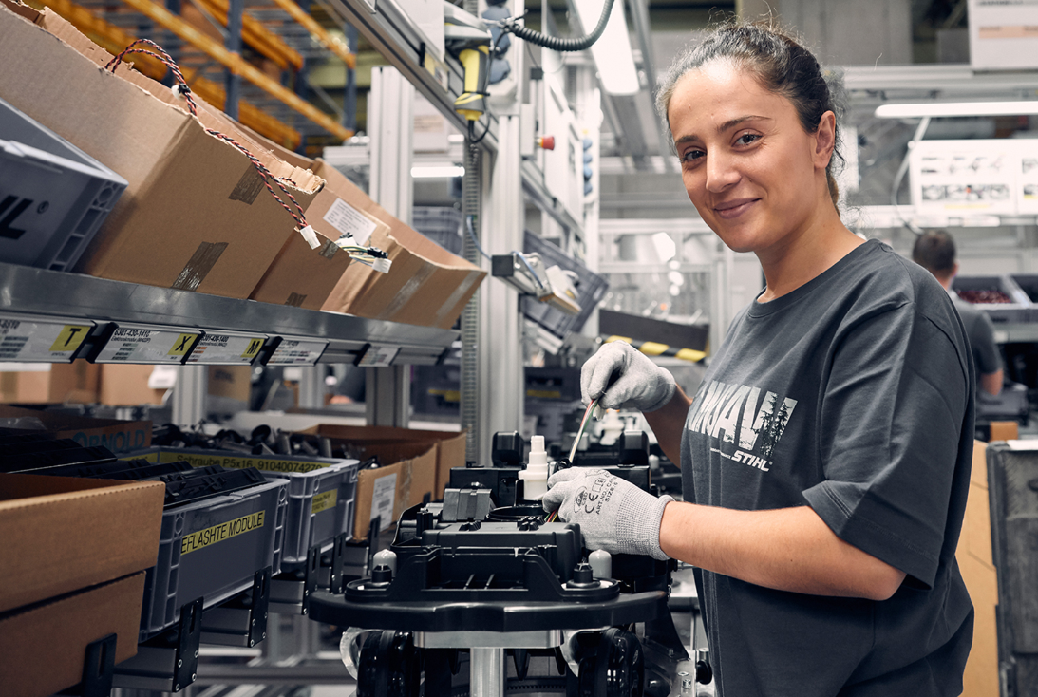
Jobs with a future
Lean structures, efficient processes and innovative forms of communication. STIHL Tirol has created an attractive working environment at the Langkampfen site.
Reprints free of charge for press purposes, photo credit: STIHL Tirol

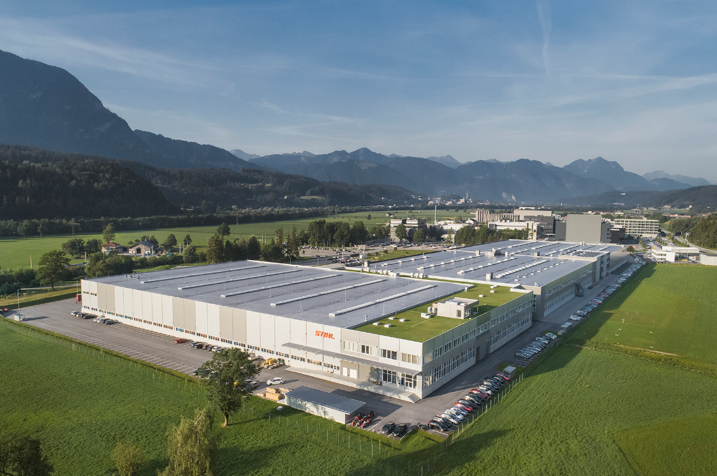
STIHL Tirol
STIHL Tirol in Langkampfen produces numerous cordless products for the world market, as well as petrol and electric tools.
Reprints free of charge for press purposes, photo credit: STIHL Tirol

