VIKING delivers a positive summary for 2012

Extensive range of new products for the current gardening season

Langkampfen/Kufstein, 24 April 2013. 2012 was another successful fiscal year for VIKING GmbH. The Tyrolean company increased its turnover by more than 6 million euros to 140 million euros. This corresponds to an increase of just under 5%. This result broke the 2011 turnover record of 133.7 million. The number of employees also rose in 2012, increasing to 317 compared with 297 the previous year. This was the highest number of employees recorded in VIKING's history, and helped the company to consolidate its position as a regional employer. The balance sheet total also increased by just under 21 per cent or 17.5 million euros, giving the gardening power tool manufacturer its biggest ever balance sheet total of 102.5 million euros. The equity ratio amounted to 55 percent in 2012.

In recent years, growth in the European gardening power tool market has been somewhat subdued due to the economic crisis. However, VIKING managed to buck this trend and increase market share last year. Export share once again increased slightly and stood at 98 per cent in 2012. "The VIKING brand is synonymous with high quality and high-performance products. This is something that our customers value. Our premium strategy has once again proved extremely successful during the last year," says Managing Director Peter Pretzsch, summarising the past fiscal year.

The company expressed a clear vote of confidence in the Tyrolean location with the extension of the company premises. After only 13 months of building work, "Construction Phase III" was completed and was officially inaugurated in October 2012. New assembly stations, a new production warehouse, workshops for prototype and equipment construction, premises for apprenticeship training activities as well as additional office space have been created on a useable floorspace of 16,600 square metres. "We were exactly on target in terms of time, costs and quality. Thanks to cooperation with regional companies, a great deal of added value remained in the region. Fortunately, we also managed to complete construction of the extension without any accidents," says Managing Director Peter Pretzsch proudly.

Innovative gardening aids – new gardening products from VIKING
Innovation and quality are a top priority at VIKING. The strong retail brand is characterised by the performance, safety and easy handling of its products. The company also continually invests in development to make its products even better. VIKING has a number of new products for the current gardening season.

In the autumn of 2012, VIKING launched the T4 Series lawn tractors onto the market. The four models offer a range of comfort features. The side discharge distributes the grass clippings directly over the lawn to fertilise the lawn evenly. This saves time and provides the soil with valuable nutrients. The ride-on mowers do not require a grass catcher box and are therefore particularly compact. They have a turning radius of only 70 centimetres. Powerful Briggs&Stratton engines guarantee high performance. The VIKING forward/reverse drive switching provides additional drive comfort ‒ by merely folding down the lever, the tractor can be moved effortlessly.

Another example of VIKING product innovation is the HB 685 tiller. Its greater engine power makes the cultivation of difficult terrain and large areas even easier. As with all VIKING tillers, the hoe set is dividable. In confined spaces, the working width can be reduced to 60 centimetres thanks to this feature. Another special feature are the blades, which operate with a cutting rather than a chopping action. This reduces vibration and the tiller runs more smoothly. The anti-vibration system between the handlebars and gearbox housing also absorbs further vibrations. The handlebar can also be easily adjusted without tools. Firstly, the height can be adapted to the user's height, thus preventing backstrain. Secondly, the handlebar can be turned to the left or right. The machine can therefore be operated without having to step on the freshly cultivated soil.

The range of mulching mowers has also been extended with the MB 4 R Series. These special lawn mowers are designed for the care of large lawns, but are also suitable for roundabouts or nature parks, for example, and are therefore ideal for semi-professional and professional use. Features such as SmartChoke, double ball-bearing wheels and excellent grip make the machines easy to operate.

There were also new product launches for the 2 Series and 4 Series lawn mowers. The 2 Series has two new models with greater cutting width. The MB 253 and the MB 253 T feature a robust design, sophisticated technology and reliable engine performance thanks to the powerful OHV engine. The MB 253 T model is also available with self-propulsion and treaded tyres. With a cutting width of 51 centimetres, these gardening aids are ideal for medium-sized lawns.

The range of 4 Series lawn mower models was completely revised and re-designed. VIKING provides a wide variety of models. To ensure that there is a machine to suit every user, this gardening aid is available with three different drive types. The petrol, electric and battery-powered mowers feature different cutting widths, power output, equipment and drive type. The 4 Series offers plenty of comfort features, including the mono-comfort handlebar, reliable power and a neat cutting pattern thanks to highlift blades. Some models in the 4 Series (with the addition of "C" in the model designation) are lawn mowers with a height-adjustable mono-comfort handlebar, featuring only one handlebar instead of the traditional two. This gives users direct and easy access to the grass catcher box. The box can be detached and attached effortlessly before and after emptying. The handlebar can also be folded forwards for space-saving storage or transport of the lawn mower. The ergonomic design and easy handling round off the overall package.

The MB 448 TC model won the "Universal Design Award" in recognition of its user-friendliness. A special feature of this internationally recognised design award is the fact that entries are assessed by both an expert panel of designers and a critical, 100-strong panel of consumers. Evaluation criteria include simple and intuitive operation, safety, degree of innovation, sustainability and environmental friendliness. "Awards like these are confirmation that the ongoing investment in the development of new products combining design and comfort is worthwhile," says Wolfgang Simmer, Sales and Marketing Manager of VIKING GmbH.

Intelligent mowing – the new iMow 6 Series
VIKING is set to launch a unique product innovation in the summer of 2013. The new iMow 6 Series robotic mowers will initially be launched in selected markets and then rolled out internationally. These gardening aids are the latest development from the Tyrolean gardening power tool manufacturer and use advanced technology. These intelligent machines recognise obstacles and boundaries and can avoid them effortlessly. The iMow operates automatically and is easy to programme for any type of garden. For users, automated lawn care means more free time. In addition, this gardening aid mows large lawns in no time at all and delivers excellent cutting performance thanks to the mulching technology used. This short mowing time gives users plenty of flexibility to adapt the mowing schedule to their specific requirements. The iMow also offers dynamic mowing schedule calculation. This means that the iMow can respond if mowing cycles are not executed due to rain, for example. The VIKING iMow also features protection against theft and unauthorised access and delivers ecological, zero-emission operation. State-of-the-art battery technology and efficient energy management complete the package.

Sustainable lawn care
Sustainability is extremely important to VIKING. The company has been awarded numerous renowned environmental labels.

The new MB 4 R mulching mower models were recently awarded the "Svanen" ecolabel ‒ a reputable Nordic and internationally renowned mark of quality with particularly strict environmental protection requirements. The special mowers scored highly in terms of avoiding pollutants and reducing noise emissions. The materials were also recognised for dispensing entirely with heavy metals and softeners. The committee comprised representatives from environmental organisations, trade, industry and state organisations from Sweden, Norway, Denmark and Iceland.

The VIKING 3 Series battery-powered MA 339 and MA 339 C lawn mowers were last year awarded the "Blue Angel" environmental label, the first environmental protection-related hallmark worldwide. The battery-powered lawn mowers stand out thanks to a specially noise-optimised blade, low-pollutant lithium-ion batteries and the absence of components made from PVC or containing plasticisers.

"For us, these awards represent further confirmation of the sustainability of VIKING products. From the planning and development stages, great value is placed on the conservation of resources," explains Managing Director Peter Pretzsch. The ecological benefit of VIKING machines is also high. This begins with the reduced noise level and extends right up to the product itself. For example, the garden shredders and mulching mowers return valuable nutrients to the soil. And, of course, the long service life of the products speaks for itself.

The issue of sustainability was also taken into consideration when extending the company premises. Ground water helps to keep the offices cool. VIKING uses LED lighting in its production, storage and outdoor areas.

Internationally successful
VIKING is one of Europe's leading manufacturers of gardening power tools and continues to increase its market share. Among the most successful sales markets in the last year were England, France, Scandinavia and Russia. In England, widely regarded as the home of lawn mowing, sales were higher than the average. VIKING performed particularly well here with models specifically designed for the market. The high quality of VIKING products is also valued in Scandinavia. The extensive product range offers ideal solutions for all geographical conditions. Mulching mowers perform particularly well in the Scandinavian markets. The sales structure in the Russian market was also optimised in the last year, thus consolidating the position of VIKING as a strong retail brand. Tillers also sold exceptionally well last year. These gratifying developments bring VIKING a further important step towards its objective of market leadership in the European specialist market.
VIKING: Successful member of the STIHL Group

As a family-run company, VIKING remains independent of decisions by third parties. VIKING has been a fully-owned subsidiary of STIHL International GmbH since 1992. Stihl has been the world's highest-selling chain saw brand since 1971. The two STIHL Group brands – STIHL and VIKING – complement each other perfectly in terms of products, and can thus exploit synergy effects. More and more of STIHL's electric products, such as numerous battery-powered machines, are produced in the plant in Langkampfen.

Nikolas Stihl assumed Chairmanship of the Advisory and Supervisory Boards of the STIHL Group on 1 July 2012. Nikolas Stihl was Managing Director of VIKING in Langkampfen from 1993 to 2011.

The STIHL Group had a successful 2012 and managed to further consolidate its excellent market position. Sales in the key product categories increased despite the weak global economy. The company also invested in future technologies and expansion of capacity last year to prepare for future growth.

VIKING management crew:

Dr. Peter Pretzsch Managing Director
Wolfgang Simmer Sales and Marketing Manager
Josef Koller Production and Market Supply Manager
Michael Dickjürgens Purchasing Manager
Bruno Lutz Finance and Accounting Manager
Johann Weiglhofer Product Development Manager

Facts & figures: VIKING at a glance

Company history
1981 Foundation of VIKING GmbH
1992 VIKING becomes a member of the STIHL Group
2001 Relocation of the company headquarters from Kufstein to the Competence Centre for Gardening Tools in Langkampfen
2007 First extension to the VIKING plant
2012 Extension for a further 16,000 m² of useable floorspace

Management
Dr. Peter Pretzsch

Product range
Lawn mowers, robotic mowers, lawn tractors, garden shredders, scarifiers, tillers as well as numerous battery-powered and electric STIHL brand products.

Business figures

 | 2006 | 2007 | 2008 | 2009 | 2010 | 2011 | 2012
Employees | 179 | 195 | 219 | 250 | 268 | 297 | 317
Turnover in thousands | 86,399 | 92,936 | 118,823 | 106,184 | 110,554 | 133,688 | 140,000
Balance in thousands | 53,471 | 57,602 | 67,420 | 65,592 | 72,748 | 84,998 | 102,500
Equity capital in thousands | 32,006 | 32,321 | 44,151 | 45,870 | 48,226 | 52,175 | 56,600
Equity ratio  in % | 60 | 56 | 65 | 70 | 66 | 61 | 55
Export share in % | 98 | 98 | 98 | 98 | 97 | 97 | 98

VIKING in short
VIKING was founded in 1981 in Kufstein and was able to continuously expand the production of its garden shredders. Three years after foundation of the company, VIKING began the development of its own line of lawn mowers in 1984. In 1992, following incorporation into the STIHL Group, the company completely renewed its garden tool range.

Today, VIKING produces and sells lawn mowers, robotic mowers, lawn tractors, garden shredders, tillers and scarifiers. With a current export share of approximately 98 percent, the garden tool specialist is represented in some 60 countries worldwide. The most important export markets are Germany, France, Russia, Belgium, Netherlands, Spain, Poland, the United Kingdom and Norway. With 317 employees, VIKING achieved a turnover of 140.0 million euros in 2012. The consistent development of high-quality products and good marketing techniques in collaboration with the STIHL Group have made VIKING a leading company in the gardening power tool sector.

Your contact for further questions:
VIKING GmbH
Christian Dag
Hans Peter Stihl-Strasse 5
6336 Langkampfen/Kufstein
Tel.: (0043) (0) 5372/6972-267
E-mail: christian.dag@viking.at
www.viking-garden.com

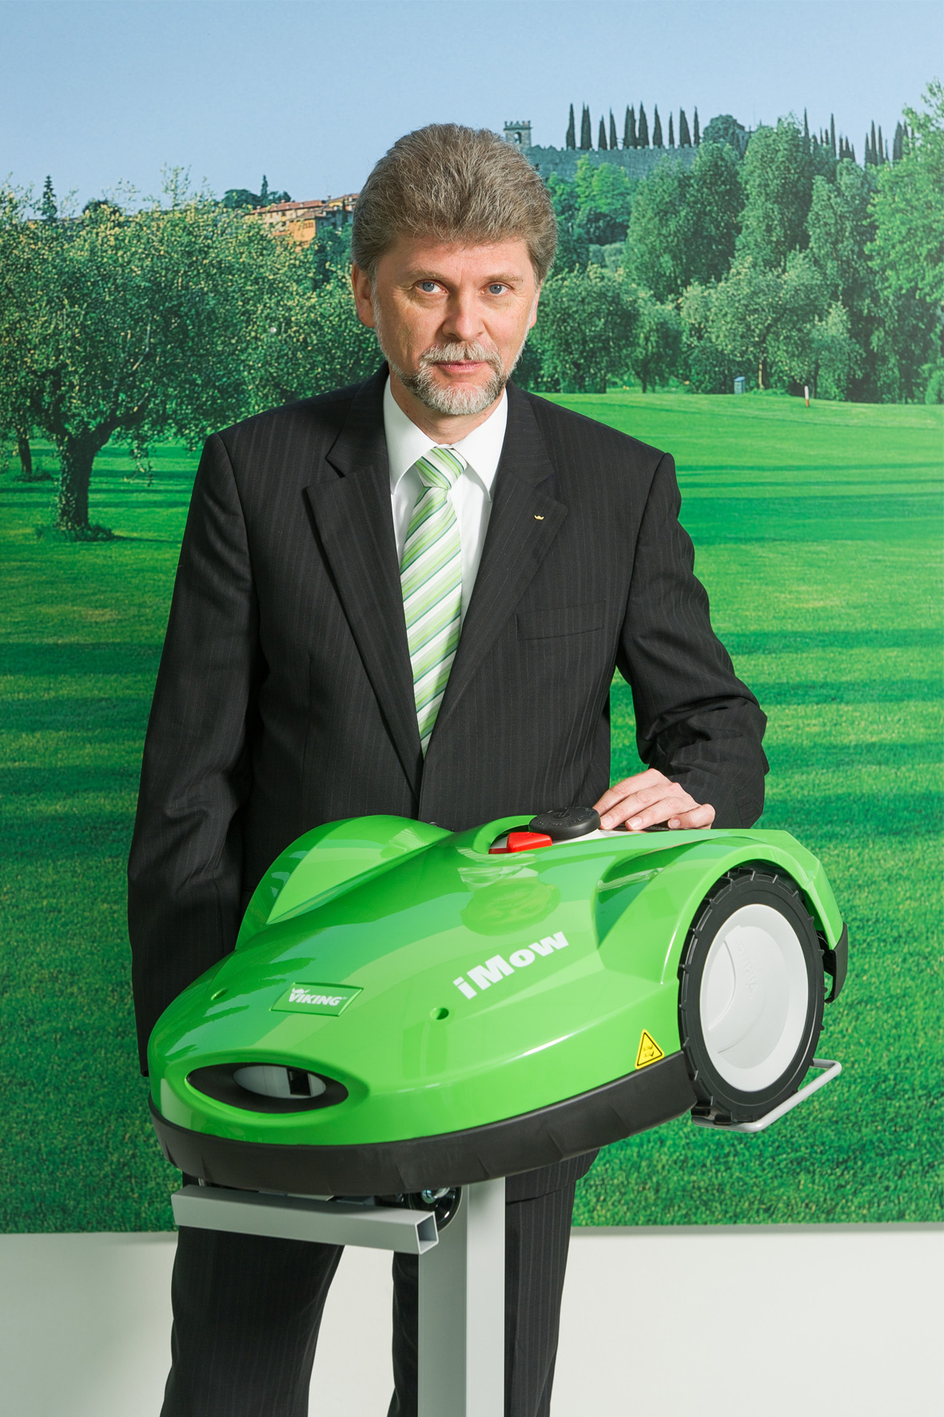 | Managing Director Peter Pretzsch  Peter Pretzsch delivered a positive summary for VIKING GmbH for the year 2012 and presented a new generation of robotic mowers, which will be launched by VIKING in the coming year.
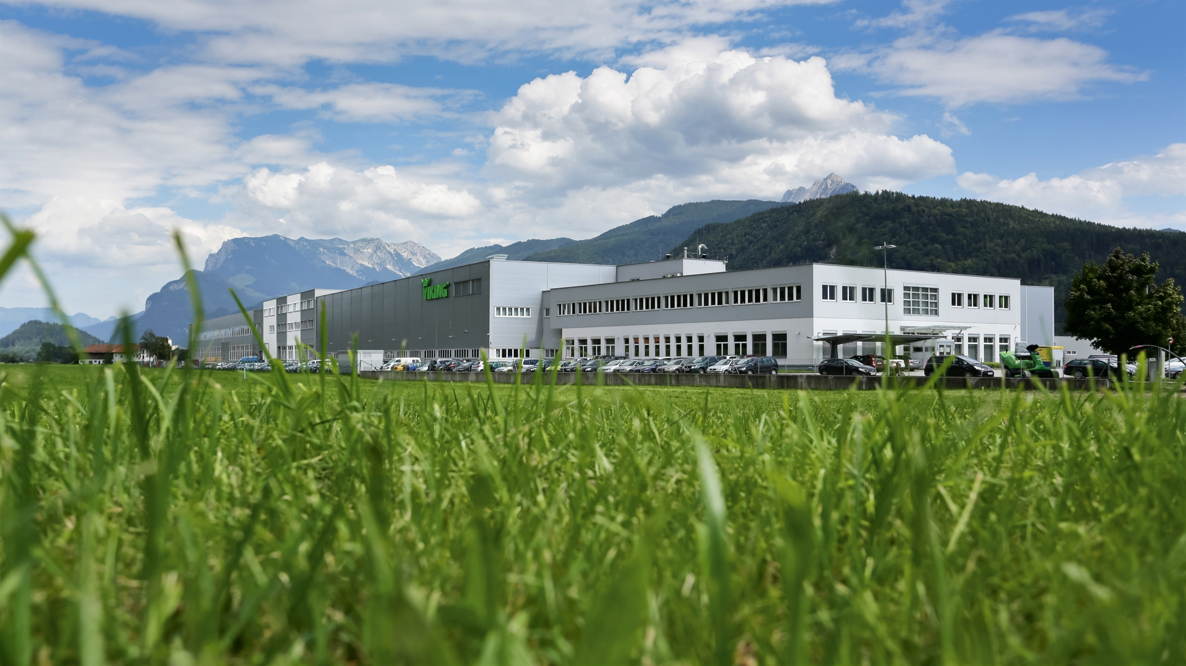 | VIKING building 2013  After only 13 months of building work, "Construction Phase III" was completed and was officially inaugurated in the autumn of 2012. New assembly stations, a new production warehouse, workshops for prototype and equipment construction, premises for apprenticeship training activities as well as additional office space have been created on a useable floorspace of 16,600 square metres.
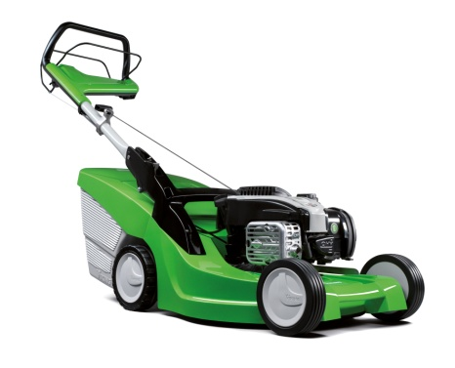 | VIKING MB 448 TC lawn mower  The MB 448 TC lawn mower, a model from the re-designed 4 Series range, recently won the "Universal Design Award". Evaluation criteria include simple and intuitive operation, safety, degree of innovation, sustainability and environmental friendliness.

