VIKING achieves over €150 million in turnover for the first time.

Successful market introduction of new gardening aids

Positive results for 2013
Langkampfen/Kufstein, 16 April 2014. VIKING GmbH has achieved positive results for 2013. It managed to boost its turnover by nearly 10%, from €140.0 to €153.9 million. This marks the first time that this company, based in the Austrian Tyrol, has surpassed €150 million in turnover: a new record for the company. VIKING's workforce is also undergoing positive development: at its current number of 329 employees, it has exceeded its 2012 level of 317. This amounts to a 3% increase. In just five years, the number of employees has increased by 31%, from 250 to 329. This development affirms the position of the gardening power tool manufacturer as a major employer in the region. At an impressive €101.8 million, its balance-sheet total is practically unchanged. In 2013, its equity ratio increased to 62%.

VIKING's export share also remained unchanged compared to the previous year, amounting to
98%. "Our investments in the VIKING brand have paid off. Over the past year, we have successfully further reinforced our position as a strong retail brand and gained additional market share. Clear motivation for us to continue with our premium strategy, including in the future," states Managing Director Peter Pretzsch, delighted by the positive development.

In addition to VIKING products, the Langkampfen Competence Centre is also increasingly producing STIHL power tools. The Langkampfen site is currently manufacturing nine battery-powered products from the STIHL group. This year has seen the addition of some new products, such as the MSA 160 T battery-powered chain saw, the HTA 85 battery-powered pole pruner and the HSA 86 battery-powered hedge trimmer. More power tools will follow over the course of this year. "This development is not only an indication of the high degree of confidence in our employees, but also a validation and reinforcement of the Langkampfen site," adds Peter Pretzsch. This synergy has enabled optimal use of the production site, which underwent a major expansion in late 2012 (Construction Phase III), and has also reduced seasonal fluctuations.

Market launches boost turnover.
Innovations bring success – this has proved true for VIKING in 2013. The gardening power tool manufacturer is drawing an above-average share of its turnover from new products. Year for year, the Tyrolean company is investing in making its product range in the garden tool sector even better and more efficient. Always in focus: high performance, easy handling, safety and comfort. Over the past gardening season, the VIKING product family has grown by almost 20 new products. The market launches for the MI 632 and MI 632 P robotic mowers and the 2 Series and 4 Series lawn mowers were especially positive.

The new iMows from VIKING are an innovative generation of robotic mowers. The initial launch of the 6 Series robotic mowers was successfully completed in Germany, Norway, Sweden and Denmark in the autumn of 2013. This intelligent gardening aid has only recently become available on the market in many other countries. The MI 632 and MI 632 P iMow models are winning consumers over with their exceptionally rapid and precise operation, their reliability and their attractive design. They are fully automatic, easy to program as desired and they get the job done fast. The main advantage for users: they save time, which means a little more quality of life. The iMow drives over the lawn with precision, without leaving a single blade of grass uncut. The cutting height can be adjusted as required, from 20 to 60 millimetres. Moreover, the robotic mowers recognise boundaries and obstacles and avoid them automatically. If it starts to rain, the iMow stops mowing and returns to its docking station. It automatically makes up for lost mowing time once the weather improves. Its powerful batteries are charged automatically and at differing rates, depending on the scheduled use. Over night, its energy stores are intentionally charged more slowly. Shortly before use, the iMow switches to fast charging. "Robotic mowers have enjoyed rapid growth on the market. Currently, we are also seeing a fast-growing segment in the motorised gardening power tool sector. That is why we are particularly pleased that the market launch last autumn was so successful. This gave VIKING a strong position, including in the robotic mower class," says Wolfgang Simmer, Sales & Marketing Manager at VIKING GmbH.

The design of the robotic mowers recently won the red dot design award, as well as the iF Design Award and the relatively new Plus X Award. As an overall concept and with its powerful performance, it emerged as the proud test winner at the Swedish product testing institute Råd & Rön.

The VIKING 2 Series lawn mowers have been expanded with two models with a larger cutting width (51 centimetres). The MB 253 and the MB 253 T are fitted with a powerful OHV engine, guaranteeing even smoother running, higher performance and longer service life. Model MB 253 T is also self-propelled, which makes mowing even easier. The 4 Series on the other hand wins consumers over with its variety of models and its comfort. These gardening aids are available in three drive types. The petrol, electric and battery-powered mowers feature different cutting widths and equipment packages.

Innovative new products for 2014
In addition to the new MI 632 and MI 632 P robotic lawn mowers, just recently introduced onto the market in many countries, VIKING is also offering other new products for the current gardening season. In the future, T5 and T6 Series lawn tractors will have a distinctly more modern look and offer even greater functionality. Thanks to their modified chassis with simplified cutting height adjustment, the ride-on mowers are now even more comfortable to operate.

The T6 Series lawn tractors are now available with a 2-blade system. This means that the blades have been offset by 90 degrees and overlap. This geometric design optimises grass feed into the grass catcher box. This overlap also provides for an excellent cutting pattern. The mowing deck and engine are even better harmonised.

And the winner is …
VIKING. The gardening power tool manufacturer has been recognised with numerous design honours in recent months. The new MI 632 and MI 632 P robotic mowers were awarded the distinction 'the best of the best' at the renowned red dot design awards: a special award granted to a select few applicants. In addition to the design, the experts also evaluate factors such as degree of innovation and functionality. Furthermore, the iMow models have also been honoured with the iF Design Award and the relatively new Plus X Award. For the iF Design Award, an international panel of experts picked winners in five categories, such as product design and packaging design. The Plus X Award is the world's biggest innovation prize for products in the fields of technology, sports and lifestyle, and honours manufacturers whose products offer added value worthy of distinction. The new design of the T5 and T6 Series ride-on mower was also granted a red dot design award. The lawn mowers also gave cause for celebration. The MA 443 C model battery-powered lawn mower received a Plus X Award and was additionally bestowed the title Product of the Year. Apart from its battery-powered technology, experts were also impressed by the machine's mono comfort handlebar.

Moreover, the high quality of VIKING's machines has just recently been verified in a variety of tests. The ME 339 model 3 Series electric mower was selected as a test winner by the German product testing institute Stiftung Warentest. Of all the machines tested, only two mowers received a 'good' quality rating. In addition to cutting quality, safety and maintenance, the testers also examined noise level and power consumption. The Swedish product testing institute Råd & Rön also gave this score to the MI 632 robotic mower. The VIKING iMow earned the highest marks and as an individual mower, achieved the top scores in three mowing tests: 'standard mowing', 'wet grass' and 'tall grass'. Here, it impressed with its large cutting width, high battery quality and outstanding performance on steep surfaces. Similar consumer testing in the Czech Republic recently achieved the same positive results.

Some more encouraging recognition came from England, the homeland of the lawn mower. The VIKING MA 339 lawn mower was awarded the designation of 'Best Buy'. This special title means that the price is right for consumers. The renowned and independent product testing and consumer organisation 'Which?' has been testing all manner products since 1957. 'In the production of our high-performance machines, we give special attention to the materials, high-quality processing and designs in order to live up the VIKING's high quality standards. Our hard work has been rewarded by the many honours bestowed upon us," says Johann Weiglhofer, Product Development Manager.

Internationally established retail brand
The high quality of VIKING products is appreciated in over 60 different countries. This gardening power tool manufacturer has managed to continuously expand its share of the core market: Europe. In the past, VIKING has been particularly successful in Germany, France, Russia, Poland, Great Britain, Norway and Sweden. In Scandinavia, this specialised retail brand has been able to achieve higher-than-average acceptance of robotic mowers. This is attributable to an affinity for new technologies in Norway and Sweden. "In past years, we have managed to further expand our position in Europe. For us, this marks another major step towards becoming number one on the specialised market in Europe," says Wolfgang Simmer, Sales & Marketing Manager at VIKING GmbH, explaining the plans for the future.

VIKING goes social.
On 20 March, the first official day of spring, VIKING also restarted its entry onto the social networks like Facebook and Google+. Through these media, information can be obtained on the company's latest news and tips for using its products or let a video whisk you away to the lush green world of VIKING. In the first four weeks alone, it attracted over 5,000 Facebook fans.

Socially engaged
People rely on a functioning economy: businesses rely on a healthy society. VIKING shoulders its social responsibilities in a number of ways. For instance, the lawn & garden equipment manufacturer employs many people with disabilities. A third of these individuals have been with VIKING for over ten years now, and two of them for over 25 years. The entire VIKING building has full disabled access.

But VIKING's social commitment is also evident in its many sponsorship programmes. In the area of social sponsorship, for instance, VIKING has enjoyed a long and close partnership supporting SOS Children's Villages since 2005. Together with STIHL Austria, it provides gardening power tools to SOS Children's Villages throughout Austria for lawn and garden maintenance. Of course, it also provides for some fun: with children's tractors and lawn mowers from its Kid Series, VIKING also brought lots of smiles to little faces.

VIKING: Successful member of the STIHL Group
As a family-run company, VIKING's decision-taking process remains independent of third-party influence. VIKING has been a fully-owned subsidiary of STIHL International GmbH since 1992. STIHL has been the world's leading brand of chain saws since 1971. The products of the two STIHL Group brands – STIHL and VIKING – complement each other perfectly, enabling them to take advantage of synergy effects. Increasing numbers of STIHL's electrical products, such as numerous battery-powered tools and machines, are produced in the plant in Langkampfen.

The STIHL group continued to grow in 2013 and is presenting new products in 2014. At its annual press conference on 29 April 2014, the company will present ground-breaking products in the area of chain saw technology.

VIKING management team:

Dr Peter Pretzsch Managing Director
Wolfgang Simmer Sales & Marketing Manager
Josef Koller Production & Market Supply Manager
Michael Dickjürgens Purchasing Manager
Bruno Lutz Finance & Accounting Manager
Johann Weiglhofer Product Development Manager

Facts & figures: VIKING at a glance

Company history
1981 Founding of VIKING GmbH
1992 VIKING becomes a member of the STIHL Group
2001 Relocation of the company headquarters from Kufstein, Austria to the Competence Centre for Lawn & Garden Equipment in Langkampfen, Austria
2007 First expansion of the VIKING plant
2012 Expansion with an additional 16,000 m² of usable floorspace

Management
Dr Peter Pretzsch

Product range
Lawn mowers, robotic mowers, ride-on mowers, garden shredders, scarifiers, tillers as well as numerous battery-powered and electrical products of the STIHL brand.

Company figures

 | 2008 | 2009 | 2010 | 2011 | 2012 | 2013
Employees | 219 | 250 | 268 | 297 | 317 | 329
Turnover in thousands | 118,823 | 106,184 | 110,554 | 133,688 | 140,000 | 153,900
Balance in thousands | 67,420 | 65,592 | 72,748 | 84,998 | 102,500 | 101,800
Equity capital in thousands | 44,151 | 45,870 | 48,226 | 52,175 | 56,600 | 63,200
Equity ratio  in % | 65 | 70 | 66 | 61 | 55 | 62
Export share in % | 98 | 98 | 97 | 97 | 98 | 98

VIKING in brief
VIKING was founded in 1981 in Kufstein, Austria, and succeeded in continuously expanding the production of its garden shredders. Three years after the founding of the company, VIKING began developing its own line of lawn mowers in 1984. In 1992, following incorporation into the STIHL Group, the company completely renewed its garden tool range.

Today, VIKING produces and sells lawn mowers, robotic mowers, ride-on mowers, garden shredders, tillers and scarifiers. With a current export share of approx. 98 per cent, this specialist in lawn & garden equipment enjoys a presence in some 60 countries worldwide. Its major export markets are Germany, France, Russia, Belgium, the Netherlands, Spain, Poland, Great Britain, Norway and Sweden. With 329 employees, VIKING achieved a turnover of €153.9 million in 2013. The consistent development of high-quality products and good marketing techniques in collaboration with the STIHL Group has made VIKING a leading company in the lawn & garden equipment sector.

Your contact for further questions:
VIKING GmbH
Christian Dag
Hans Peter Stihl-Strasse 5
A-6336 Langkampfen/ Kufstein Austria
Tel.: (0043) (0) 5372/6972-267
email: christian.dag@viking.at
www.viking.at
www.viking-garden.com

VIKING
Annual press conference
Image title

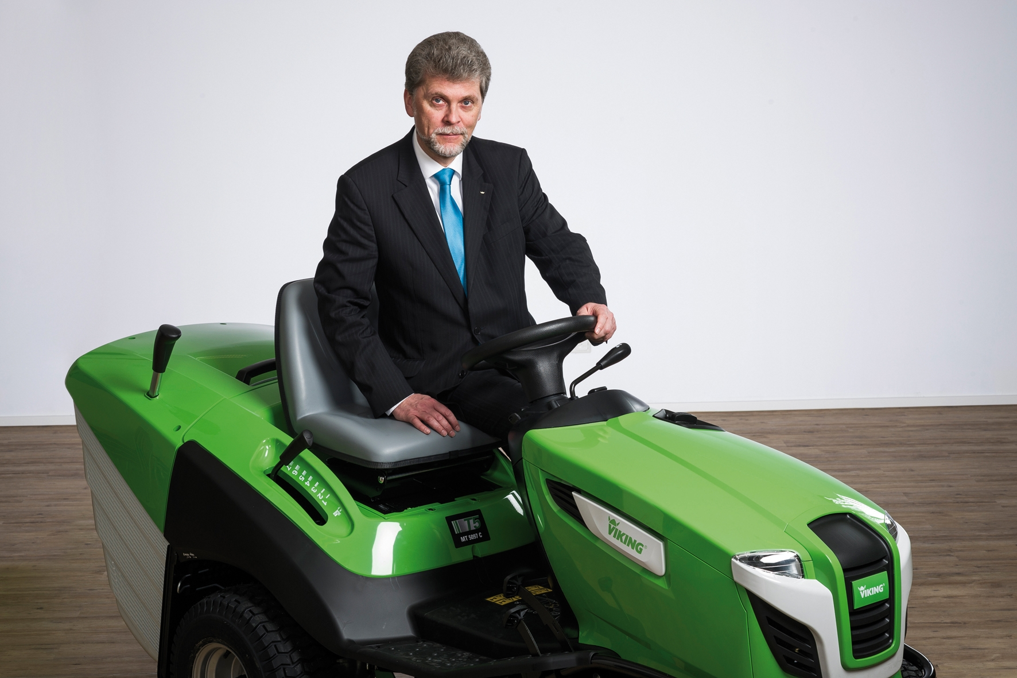 | VIKING Managing Director, Peter Pretzsch  Peter Pretzsch assumed general management of VIKING GmbH in 2011. VIKING has been a member of the STIHL Group since 1992.
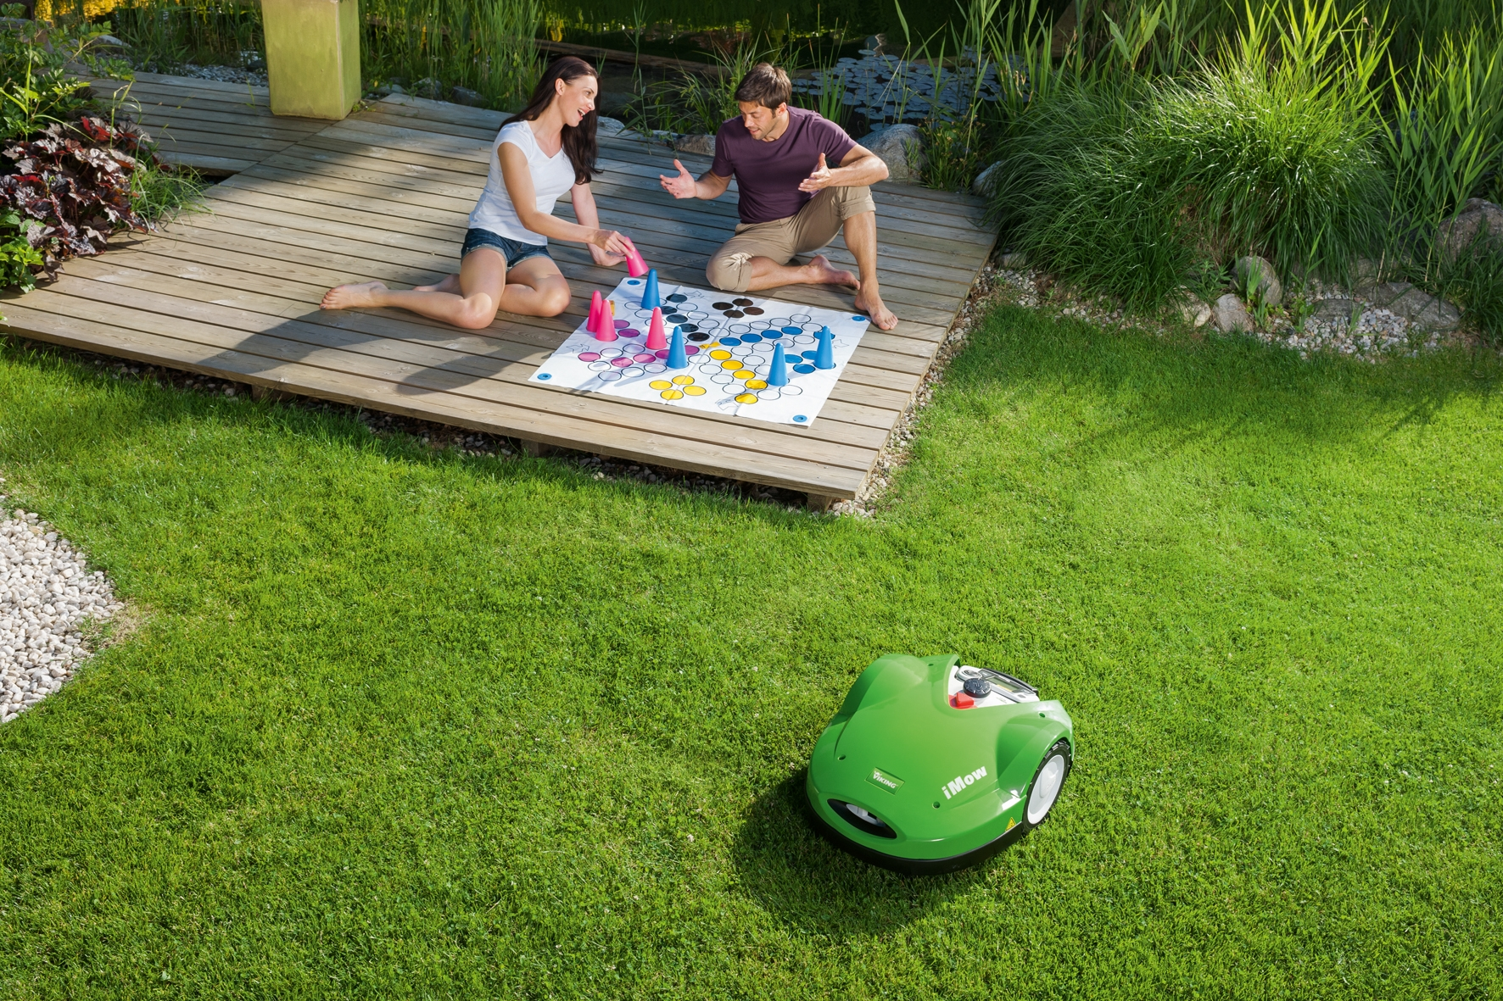 | VIKING MI 632 and MI 632 P robotic mowers  The new MI 632 and MI 632 P iMow robotic mowers from VIKING are fully automatic and get the job done fast. The main advantage for users: they save time, which means a little better quality of life.
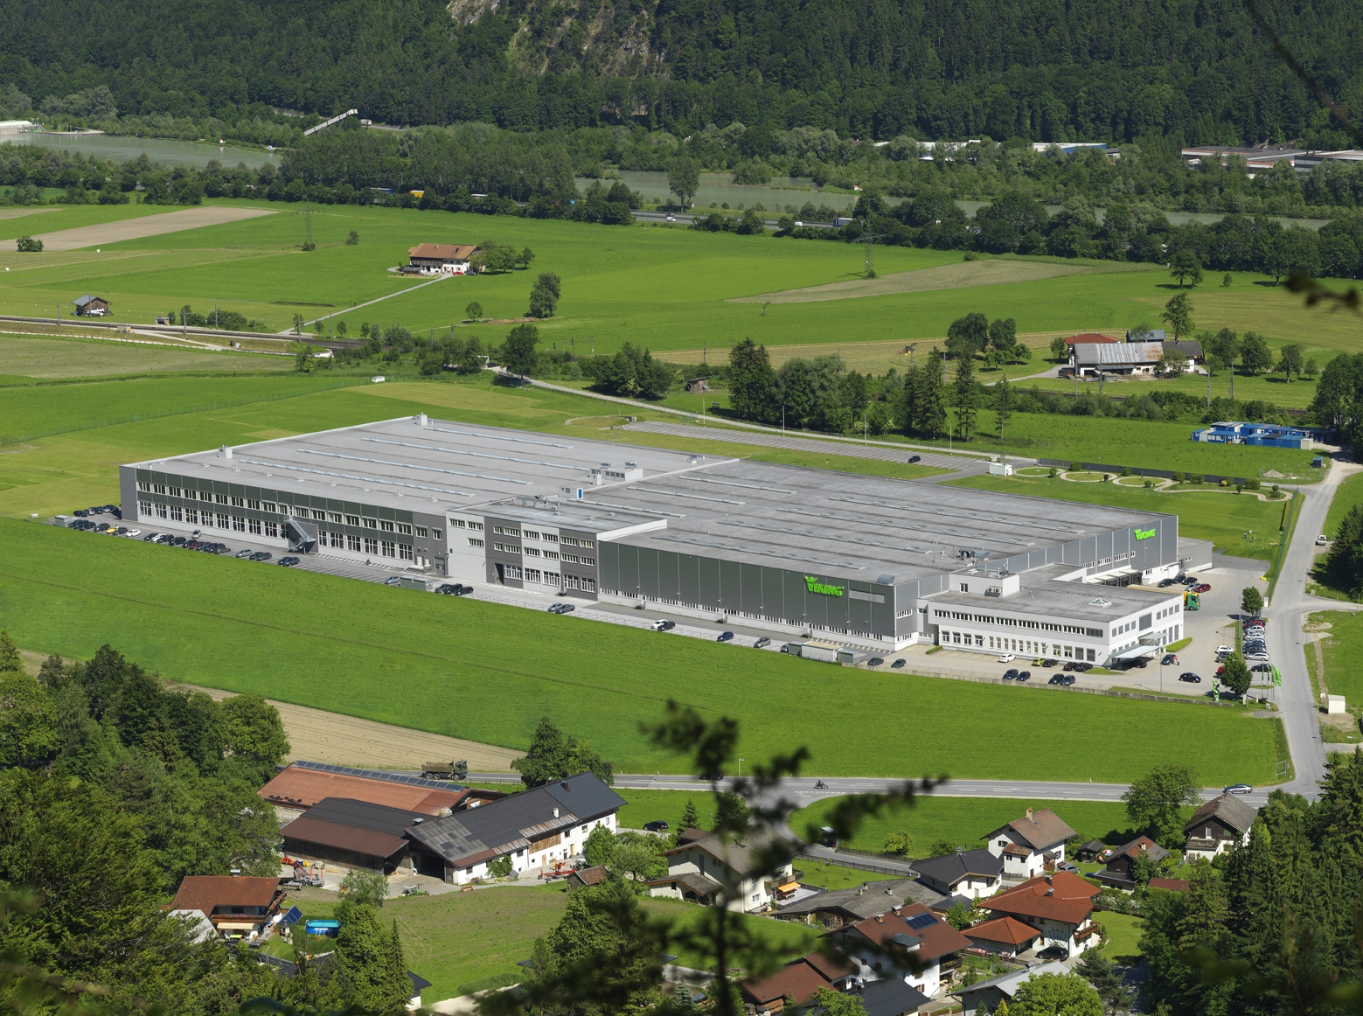 | The VIKING building  In 2013, VIKING employed 329 employees at its plant in Langkampfen, Austria.

Copyright: VIKING, reprint for press purposes free-of-charge

